TASK # 1

Q1. Write a recursive function which computes the table of N (any integer) up to 10

#include<iostream>

using namespace std;

void print(int x,int y)

{

if(y < 11)

{

cout<< x <<" \* "<< y << " = " << x\*y <<endl;

y++;

print(x,y);

}

if(x==10)

return;

}

int main()

{

int a,b=1;

cout<<"Enter a number for table "<<endl;

cin>>a;

print(a,b);

system("pause");

return 0;

}

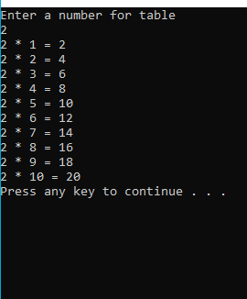

Q2. Write a recursive function which draws a square of n x n.

#include<iostream>

using namespace std;

void abc(int a,int b,int c)

{

int z=a\*a;

if(a!=b)

{

cout<<" \* ";

c++;

b++;

abc(a,b,c);

if(b==a)

{

cout<<endl;

if(c!=z)

{

b=0;

abc(a,b,c);

}

}

}

}

int main()

{

int n1,n2=0,p=0;

cout<<"Enter the Number for Square ";

cin>>n1;

abc(n1,n2,p);

system("pause");

return 0;

}

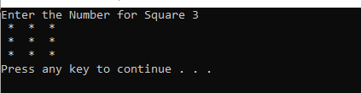

Q3. There are 100 copies of function Sum. Each copy contains a number form 1 to 100. write a recursive function such that when recursive calls back track and reaches first copy the 1st copy should have sum of all other copies. The first copy multiplies the sum with 2 and returns the result to main function. Print the result in main Funciton.

#include<iostream>

using namespace std;

int print(int a, int b)

{

if (a == 0)

return 2\*b;

b++;

print(a - 1, b);

}

int main()

{

int copy;

copy=100;

cout <<"The copies = "<< print(copy , 1)<<endl;

system("pause");

return 0;

}

